General Purpose of the Program:

To reformat an excel spreadsheet.

1. Select the **“Harvest”** button in the control panel window.

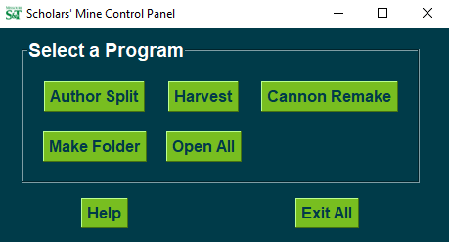

1. A window will appear and looks like this.

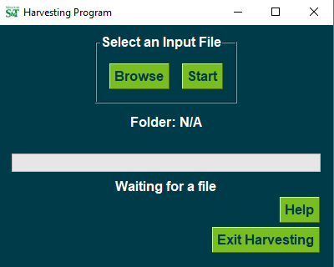

1. Click the **“Browse”** button to search for a file.



1. Once the desired folder is located, click **“Open”**.
   1. Make sure that the excel files have the **“.xlsx”** extension. Openpyxl, open source code utilized in this program, will not work for older excel files that have the extension **“.xls”**.

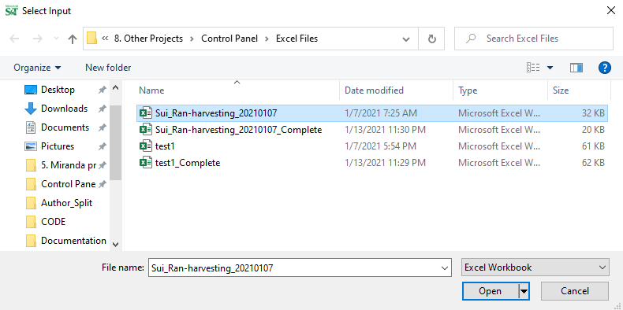

1. The file name will appear in the window. Click on the **“Start”** button to begin.

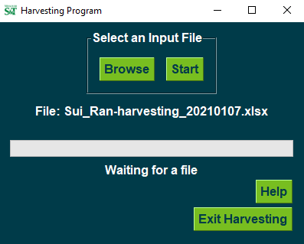

1. The progress bar will update when complete.
   1. All processed files will be saved to R:\storage\libarchive\b\1. Processing\8. Other Projects\Control Panel\Excel Files. The saved files will have the same name as the original files “_Complete” added to the end.

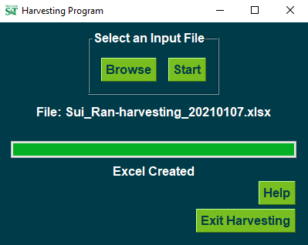

1. To repeat this program, select another folder with the **“Browse”** button and refer to step 3.
2. If you need to refer to this document, select the **“Help”** button at any time.



1. When you are done with the program you can either use the **“X”** at the top right corner of the window or press the **“Exit Harvesting”** button.

